**Chapter One: LAW, legal System, Ethics**

**What is Law?**

If you search the Internet, you will find several variations as to the meaning of “Law”.

Here are some definitions:

1. Any system of regulations to govern the conduct of the people of a community, society or nation, in response to the need for regularity, consistency and justice based upon collective human experience.

The People's Law Dictionary by [Gerald and Kathleen Hill](http://dictionary.law.com/Default.aspx?review=true#hill) (<http://dictionary.law.com/Default.aspx?review=true#hill>)

2. That which is laid down, ordained, or established. A rule or method according to which phenomena or actions coexist or follow each other.

3. A system of principles and rules of human conduct, being the aggregate of those commandments and principles which are either prescribed or recognized by the governing power in an organized society as its will in relation to the conduct of the members of such society, and which it undertakes to maintain and sanction and to use as the criteria of the actions of such members.

"Law" is a solemn expression of legislative will. It orders and permits and forbids. It announces rewards and punishments. Its provisions generally relate not to solitary or singular cases, but to what passes in the ordinary course of affairs. Civ. Code La. arts. 1. 2. "Law," without an article, properly implies a science or system of principles or rules of human conduct, answering to the Latin "jus;" as when it is spoken of as a subject of study or practice. In this sense, it includes the decisions of courts of justice, as well as acts of the legislature. The judgment of a competent, court, until reversed or otherwise superseded, is law, as much as any statute. Indeed, it may happen that a statute may be passed in violation of law, that is, of the fundamental law or constitution of a state; that it is the prerogative of courts in such cases to declare it void, or, in other words, to declare it not to be law. Rurrill.

4. A rule of civil conduct prescribed by the supreme power in a, state. 1 Steph. Comm. 25; Civ. Code Dak.

Black's Law Dictionary Free 2nd Ed. and The Law Dictionary <http://thelawdictionary.org/law>

For a lengthy discussion on “Law” you can visit: <http://en.wikipedia.org/wiki/Law>

Within variations of definitions, I think we all can agree that Laws should be reasonable. And, this is what the courts say, ‘laws must be reasonable’. But, by whose standard? A Mad Hatter’s or a Hare’s standard? No, generally, the law holds “by a reasonable prudent person’s standard”. More on this topic in a later Chapter.

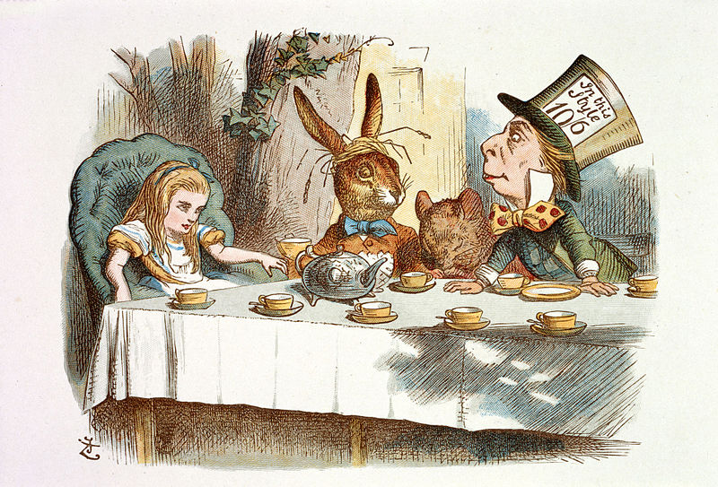

**Why are there Laws?**

To provide **reasonable expectations**, which yield stability, and to aid in providing for societal and individual general safety!

*Example:* The Law says that a red light tells a driver to stop in order to protect other drivers from a possible accident. If the driver does not stop at the red light, he should be aware that legal consequences could be a fine and possibly jail time, as well as a potential law suit from any person he injuries due to his failure to abide by the Law. We expect others to stop at a red light or face the consequences. To mandate that everyone stop at a red light provides for the general safety of all travelers. Travelers know what to reasonably expect and anticipate regarding other travelers’ actions by such mandates.

**History of law**

For in-depth see: http://en.wikipedia.org/wiki/Legal_history

Dating as far back as 3000 BC Ancient Egyptian law, there was a written civil code, which was probably broken into twelve books. [http://en.wikipedia.org/wiki/Ancient_*Egypt*](http://en.wikipedia.org/wiki/Ancient_Egypt)

The earliest lawbook was written about 2100 B.C. for Ur-Nammu, , an ancient Sumerian ruler, who was king of Ur, a Middle Eastern city-state. By the 22nd century BC, Ur-Nammu formulated the first law code, consisting of casuistic statements ("if... then..."). (“If you do this, then this will happen to you.”)

Around 1760 BC, King Hammurabi further developed Babylonian law by **codifying** and inscribing it in stone. Hammurabi placed several copies of his law code throughout the kingdom of Babylon as **stelae**, for the entire public to see; this became known as the Codex Hammurabi ,or Code of Hammurabi. The term "eye for an eye" comes from the Code of Hammurabi**.**  Eventually, each area or the world followed suit, writing down laws, or words that govern its society.

**Codifying**: 1. to reduce (laws, rules) to a code. 2. to make a digest of; arrange in a systematic collection.

Courts still do this today!

**Stelae**: stone or wooden slab, generally taller than it is wide, erected as a monument.

The United States legal system developed primarily out of the English Common law system. The four-volume Commentaries on the Laws of England by Sir William Blackstone (completed in 1769) was the legal "bible" for all American frontier lawyers.

The English common law system and most European systems were influenced by the Justinian Code, which was the law of the Roman Empire handed down by Roman Emperor Justinian in 528 and completed by 534. The English common law system evolved from a combination of Anglo-Saxon law and Norman law, much of which was by custom and precedent rather than by written code.

However, in the United States, the State of Louisiana adopted many aspects of the French Law. Likewise, Arizona, Nevada, Texas, California, and New Mexico were influenced by Mexican Laws, especially community property laws.

Community property laws dictate that most property acquired during the marriage (except for gifts or inheritances) is owned jointly by both spouses and is divided upon divorce, annulment, or death. Joint ownership is automatically presumed by law in the absence of specific evidence that would point to a contrary conclusion for a particular piece of property. <http://en.wikipedia.org/wiki/Community_property>

In contrast, States that do not follow Community Property laws employ the concept ‘what is legally acquired by you is yours, regardless as to when it was acquired’. It does not have to be shared by your spouse unless you have an arrangement to do so, or a court deems spousal support is required due to the unique circumstances in the particular situation.

The following states have community property laws Arizona, California, Idaho, Louisiana, Nevada, New Mexico, Texas, Washington, and Wisconsin. Knowing if you are in a State that follows Common Law can be important in debt situations or business matters. As an example see: <http://www.courts.ca.gov/1039.htm>

**How is the American Legal System structured?**

**Four primary sources of Law**

In the United States, there are four primary sources of law.

1. Constitutions
2. Statutes
3. Common Law
4. Administrative Law

Listed below is the general hierarchy of law in the United States. These laws are named relative to the authority the law holds.

* **US Constitution**.......................What did the people of the United States say?
* **Supreme Court case holdings ...** What did the Judge say?
* **Congressional Statutes ...........**What did Congress say?
* **Executive Orders .....................**What did the US President say?
* **Regulations ..............................**What did a Federal Administration, Agency, or Dept say?
* **Appellate case holdings**  ........What did the Judge say?
* **District Court holdings .........** What did the Judge say**?**
* **State Constitution .................** What did the people of this particular State say?
* **State Supreme Court .............** What did the Judge say?
* **State Statutes**  ...........................What did a particular State Legislature say?
* **State Regulations ......** What did a particular State Administration, Agency, or Dept say?
* **Ordinances** ...........................What did a particular City or County Say?

**Constitutions**

The United States Constitution is the Supreme Law of the Land. It delegates certain powers to the Federal government. All other powers belong to the States. Each State has its own Constitution that governs as the Supreme State law.

**Statutes**

Next, in the hierarchy, there are Statutes. Federal Statutes are created and ratified in the Federal legislative process that is delegated to Congress (Senate & House of Representatives) by the US Constitution. In State matters, State Statutes are formed from the State legislature process delegated by the State Constitution. Of course, Federal Statutes trump State Statutes.

State Statutes can impose more stringent restrictions or requirements than a Federal Statute. Example, Under the Endangered Species Act of 1973, the federal program maintains a list of endangered or threatened animals that must be protected. Federal law serves as a floor, establishing the minimum a state may do to protect species on these lists, and the minimum number of animals on these lists. However, States, such as Florida, may have their own plans creating more stringent protections for the animals on the Endangered Species or can designate additional animals as threatened or endangered that shall be protected in Florida.

Under the hierarchy of Stated Statutes, there are City and County ordinances. These too are laws (statutes) passed by City councils and County Councils.

Statutes can be challenged under many theories, such as the statute is too vague, too broad, too restrictive, or violates a Constitutional Right. For a detailed discussion, see <http://en.wikipedia.org/wiki/Facial_challenge> or research the Internet.

**What happens if a Statute is challenged?**

All statutes, including Federal, State, City, or County can be overturned by a Court with higher authority. A State law can be overturned by that State’s Supreme Court or by the U.S. Supreme Court. Whereas, Federal law cannot be overturned by a State court, but may be overturned by the U.S. Supreme Court.

For Federal civil rights statutes overturned see <http://www.pbs.org/wnet/jimcrow/stories_events_uncivil.html>

Similarly, the Defense of Marriage Act of 1996, a Federal statute signed by Bill Clinton, barred the federal government from recognizing same-sex marriages legalized by the States. It was deemed unconstitutional by the Supreme Court by a 5-4 vote. (*United States v. Windsor*, 570 U.S. (2013) Edith Windsor was the 84-year-old woman who brought the case before the Courts. <http://en.wikipedia.org/wiki/United_States_v._Windsor> <http://en.wikipedia.org/wiki/Defense_of_Marriage_Act>

An example of where several State statutes were overturned is when the U.S. Supreme Court overruled the previously existing abortion laws. In 1821, Connecticut passed the first state statute criminalizing abortion. Every state had abortion legislation by 1900.

However, along came *Roe v. Wade* in 1971. The Court issued its decision on January 22, 1973, with a 7-to-2 majority vote in favor of Roe, deeming abortion a fundamental right under the United States Constitution, thereby subjecting all laws attempting to restrict it to **the standard of strict scrutiny**. <http://en.wikipedia.org/wiki/Roe_v._Wade>

**Notice that the Supreme Court used the “Strict Scrutiny” Standard of review in *Roe v. Wade*. This means they used the most stringent method to review the laws in question, as it was a very important constitutional right involved in the case.**

Since this is an introductionary law course, we will only introduce that t**here are three different levels of review utilized by courts when reviewing laws and policies. Which one the Court will apply depends on the rights or processes involved.** Based on the standards of review that needs to be applied, a different level of proof will need to be proffered to support a claim against the particular law or policy at hand (issue in the case being adjudicated).

1) **Strict Scrutiny standard** is the most rigorous form of judicial review typically used when Constitutional rights, Fundamental right, political process distortion/rigging, or minorities’ discrimination may be at issue. The proof required is that

* The law or policy serves a compelling state (governmental) interest **and**
* is narrowly tailored to achieve its result. (specific to that issue and no broader)

2) **Intermediate scrutiny**, is in the middle and is normally applied when gender or sex discrimination may have occurred. The proof required is that

* The law or policy serves an important government objective, **and**
* is substantially related to achieving the objective. (Only related to the desired objective)

3) **Rational Basis test** is the lowest form of judicial scrutiny for challenges that do not warrant Strict or Intermediate scrutiny. It is very easy for the Court to uphold a law or policy being challenged under the Rational Basis test. Under this review, the person challenging the law or policy (not the government) must prove either:

* The government has no legitimate interest in the law or policy; or
* There is no reasonable, rational link between that interest and the challenged law/policy.

For more on this topic, research the Internet. Some helpful links are: <https://en.wikipedia.org/wiki/Strict_scrutiny>, <https://en.wikipedia.org/wiki/Intermediate_scrutiny>, <https://en.wikipedia.org/wiki/Rational_basis_review>,

[http://blogs.findlaw.com/law_and_life/2014/01/challenging-laws-3-levels-of-scrutiny-explained.html#sthash.HSVikIfn.dpuf](http://blogs.findlaw.com/law_and_life/2014/01/challenging-laws-3-levels-of-scrutiny-explained.html%23sthash.HSVikIfn.dpuf)

**Common Law or Case Law**

The third primary law source, Common Law or Case Law, stems from decisions of judges on cases, and often incorporate customs and practices. Once a decision is made, all lateral or lower judges follow that same reasoning and decision. This is called the Principle of Stare Decisis (Let the Decision Stand). Case decisions under the Principle of Stare Decisis create a “precedent”, meaning that decision is either binding or persuasive for other courts or tribunals when deciding subsequent cases with similar issues or facts. In other words, other lateral and lower courts are to follow the decision until such time as society changes mandate a different judgment. However, a higher court may choose to decide differently, and then that new decision would become precedent. Precedents help create stability by allowing society to know what to expect. <http://en.wikipedia.org/wiki/Precedent>

A change in Precedent does happen, but rarely. The U.S. Supreme Court has overruled 228 of its own decisions over the years. See <http://research.policyarchive.org/2646.pdf> or handout.

For instance, *Plessy v. Ferguson* (1896), the U.S. Supreme Court said separate but equal. But, later in 1954, *Brown v. Board of Education*, the Court held that racial segregation in the public schools was inherently unequal. Separate cannot be equal. “Whatever may have been the extent of psychological knowledge at the time of Plessy v. Ferguson, this finding [that racial segregation stigmatizes minority children] is amply supported by modern authority. Any language in Plessy v. Ferguson contrary to this finding is rejected.” (347 U.S. at 494-95) American Society had changed and the US Supreme Court changed with it.

Common Law (Court’s legal decision based on the facts of a case) is often codified into Federal or State Statutes. Sometimes a Court’s decision strikes against the cord of society, and thus statutes are enacted to protect against judges making similar decisions in the future. Such happened after ***Kelo v. City of New London***, [545 U.S. 469](http://en.wikipedia.org/wiki/Case_citation) (2005).

In ***Kelo v. City of New London***, the U.S. Supreme Court allowed the local city government to utilize eminent domain to take land away from a private land owner. The Court used the rational that the general benefits a community enjoyed from economic growth qualified private redevelopment plans as a permissible "public use" under the Takings Clause of the Fifth Amendment. Here, the City transferred land ownership from one private owner to another private owner in the ‘name of furthering economic development’ without the consent of the original landowner. Of course, the original landowner was given a monetary amount the City thought was a fair amount of money for the property. However, the original landowner did not think the amount given for the property was fair.

As a result of what happened in ***Kelo v. City of New London***, many States enacted legislation to protect homeowners from over aggressive eminent domain actions. As of 2012, 44 states had enacted some type of reform legislation in response to the Kelo decision. <http://en.wikipedia.org/wiki/Kelo_v._City_of_New_London>

**Administration law**

Administration law flows from the executive power of the Executive Branch. Under the Federal system, the President rules. Under the State systems, the Governor rules. The executive branch creates agencies, departments, bureaus, groups, and divisions. Examples on the federal level that you may be familiar with are:

* Occupational Safety and Health Administration (OSHA) <www.osha.gov>
* Federal Communications Commission (FCC) <www.fcc.gov>
* U.S. Food and Drug Administration (FDA) <www.fda.gov>
* U.S. Equal Employment Opportunity Commission (EEOC) <www.eeoc.gov>

These entities then create ***regulations***. Almost all government and state agencies have numerous regulations that the employees must follow. These regulations are examples of Administration laws.

For instance, the Department of Veterans Affairs is under the Executive Branch (US president). In order for the VA to write a contract to buy something (services or commodities), it must follow the Federal Acquisitions Regulations as well as the Veterans Affairs Acquisitions Regulations.

**To summarize**, the various primary sources of American law are enforced according to the following hierarchy:

1. The United States **Constitution** takes precedence over
2. Federal **statutory** law, takes precedence over
3. Federal **administrative rules and rulings – in some circumstances**- take precedence over
4. a State **Constitution**, takes precedence over
5. a State **statutory** law, which takes precedence over
6. a State **administrative rules and rulings**, which could take precedence
7. a local ordinance, (county, city)

**COMMON LAW fits in by interpreting the above.**

**Also, common law trumps (takes precedence) if the above sources have not addressed the legal issue(s) at hand (presented by the court case)!**

A current example of the above precedence hierarchy is the federal law verses many of the States statutes regarding current medical use of marijuana. Under the federal Controlled Substances Act (CSA) of 1970, marijuana is classified as a Schedule I substance. By definition, Schedule I drugs have a high potential for abuse and dependency, with no recognized medical use or value. Any marijuana possession, cultivation, or use is a federal crime, subjecting a defendant to fines, prison time, or both. Thus, while a State law may allow medicinal marijuana cultivation, possession, and use, the federal government can prosecute people under its laws. Clearly, the federal CSA and many State medical marijuana laws are in direct conflict. In this case, the federal CSA regulation will trump the State law.

https://www.whitehouse.gov/ondcp/state-laws-related-to-marijuana (See supplemental instructor hand outs)

What laws govern, and when they govern, can get very confusing. An interesting read on this topic can be found at: http://www.newsweek.com/conflict-between-federal-and-state-marijuana-laws-claims-victim-345099

1The United States chain of command is as follows - See the below chart

**United States Constitution**

Legislative Branch

Judicial Branch

Executive Branch

House of Representatives

Senate

President

US Court of Appeals (11 including DC)

 US Supreme Court

 U.S. District Courts

(94 Districts)

US Court of Appeals for the Federal Circuit

 U.S. Bankruptcy Courts

(One in each district)

US Court of International Trade

US Tax Court

US Court of Appeals for Veterans Claims

US Court of Federal Claims

IRS Appeals Office

US Court of Appeals for the Armed Forces

Executive Agencies- EPA, FCC, etc…

Courts of Criminal Appeals for Military

Court Martial

**Federalism & Checks and Balances**

The three branches are equal, but separate. For instance, the Supreme Court balances the Executive and Legislative branches by making the decision on whether a Statute passed by Congress or any administrative law created by a Congressional tier or Executive tier, is unconstitutional. The Supreme Court also regulates the other two branches by interpreting laws created by the other two because sometimes a law is written so that it could have multiple meanings, just like the words in the English language. Thus, the Supreme Court weighs in if there is any confusion on a matter brought before it.

An example of a word with many meanings is crane: There is a white bird called a crane. - A crane is a mechanical machine that is used to lift an object. – A person can crane (stretch) his or her neck to see something.

Additionally, each Lower Court must listen to the Higher Court’s decision. In any case hearing, where there is a past similar case heard by a High Court, the Lower Court must apply the same decision as the previous Higher Court did. This keeps chaos from ensuing, as would happen if each court ran around making different decisions on similar facts and situations. Consistency is a must!



<http://www.uscourts.gov/about-federal-courts/court-role-and-structure>

States follow a similar hierarchy as the Federal government. There is always a State constitution, Legislative body, Judicial body and an Executive body.

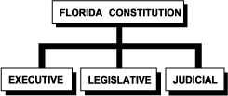

Read up on Florida’s structure at [http://fcit.usf.edu/florida/lessons/stategov/stategov.htm](http://fcit.usf.edu/florida/lessons/stategov/stategov.htm%20)

Likewise, the State court structures are similar to each other.

See Florida court structure in the below picture.



<http://www.flcourts.org/florida-courts/trial-courts-county.stml>

**Basic Concepts that comprise the American legal system**

Court Hierarchy

Court hierarchy or level dictates the extent to which a decision by one court will have a binding effect on another court. The federal court system, for instance, is based on a three-tiered structure, in which the United States District Courts are the trial-level courts; the United States Court of Appeals is the first level court of appeal; and the United States Supreme Court is the final arbiter of the law. All Courts lower courts will be bound by the higher Court’s decision. See page six and seven of this chapter.

Dual Court Systems

The American legal system is based on a system of federalism, or decentralization. While the national or “federal” government itself possesses significant powers, the individual states retain powers not specifically enumerated as exclusively federal. Most states have court systems, which mirror that of the federal court system.

Decentralization

The United States system of Federalism is based on a United States constitutional division of authority between the Federal government and State governments, with each retaining significant, but separate authority. In areas that one has been provided dominant powers by the U.S. Constitution, the other will abdicate to the higher power. For instance, in areas of interstate commerce, the U.S. Federal Congress holds power to regulate and so States cannot create any conflicting statute regarding interstate commerce.

Jurisdiction

The formal power of a court to exercise judicial authority over a particular subject matter of a case or claim. See previous charts.

Precedent—The Principle of Stare Decisis – Let the Decision stand

Courts will typically follow the decisions of higher level courts within the same jurisdiction to facilitate more predictable, consistent judgments and expectations of laws. Following what has been decreed gives uniformity to the law. If society changes, though, then a court may render a decision that does not follow a previous precedent. Thus, a new precedent may be established. This is rare, but the law does attempt to reflect current societal values and norms. However, the United States Supreme Court is the Supreme Law of the land and no lower level court may hold a judgment that is inconsistent with the United States Supreme Court’s previous holdings.

Mandatory/Binding versus Persuasive Authority

Some sources of law are considered to be “mandatory” or “binding,” while other sources are considered to be merely “persuasive.” A court may entirely disregard a precedent that is not binding and does not even have to allow it in as persuasive.

An example of a Binding authority would be higher Court decisions. Persuasive Authorities are lateral or lower court decisions on a matter that has not been reviewed at the current court.

Primary versus Secondary Authority

The sources of law may be broken down into primary and secondary sources. Primary sources may be mandatory on a particular court, or may be merely persuasive. Whether the particular source of law is binding or persuasive will depend on various factors. A secondary authority is not law and is never a mandatory authority. A court, however, may look to secondary law sources for guidance on how to resolve a particular issue. Secondary authority or sources include materials that explain or comment on **areas of law** such as ‘law-reviewarticles’ written by legal experts, treatises, hornbooks, legal dictionaries or legal encyclopedias. Secondary authority may be useful as a case finding tool and for general information about a particular issue. A very well-known popular legal dictionary is Black’s Law Dictionary. It was first published in 1891, and has since had many updated editions. It has even been cited as a secondary legal authority in many U.S. Supreme Court cases!

**Two Areas of Law ..... Civil or Criminal Law?**

In the United States, we have two Areas of Law: Civil Law and Criminal Law. We can think of it as two separate rooms with two different entry doors. Behind each door are many laws. Some of those laws are very similar or even the same! But each room has its own purpose and own procedure. The way in through the door may appear similar at first glance, but the knob on each turns completely different.

Civil Law Door # 1 will open for anyone or any entity with a reasonable lawsuit. But, Criminal Law (Door # 2), only opens for an official member of the government who has been empowered by the law to prosecute a defendant (person or entity) for crime(s). It could be a Federal or State Prosecutor who decides if there is enough legal and a severe enough crime to pursue spending taxpayer money to prosecute the defendant. See http://www.americanbar.org/publications/criminal_justice_section_archive/crimjust_standards_pfunc_blk.html for more information or conduct your own online research.

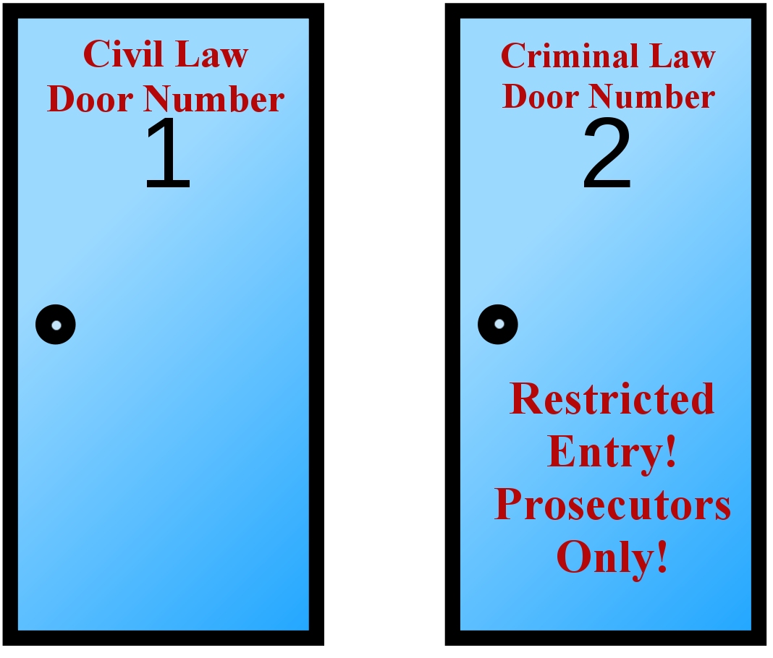

**Comparison chart**

|  | **Civil Law**  **Wrong to an individual** | **Criminal Law**  **Wrong to Society** |
| --- | --- | --- |
| **Definition** | Civil law deals with the disputes between individuals, organizations, or any combination of the two, in which compensation is awarded to the victim. | Criminal law is the body of law that deals with crime and the legal punishment of criminal offenses. |
| **Purpose** | To deal with the disputes between individuals, organizations, or between the two, in which compensation is awarded to the victim. | To maintain the stability of the state and society by punishing offenders and deterring them and others from offending. |
| **Case filed by** | Private party | Government |
| **Decision** | Defendant can be found liable or not liable.  The case may be heard only be a judge (bench trial) or by a jury. Usually, only a judge is necessary. | Defendant is convicted if guilty and acquitted if not guilty.  The case may be heard only be a judge (bench trial) or by a jury, depending on the severity of the crime and potential punishment the defendant is facing. |
| **Standard of proof** | "Preponderance of evidence." Claimant must produce evidence beyond the balance of probabilities. 51% likelihood that Defendant has committed the civil wrong.  Why is the proof lower on this side?  The defendant is only at risk for money damages or an injunction to stop doing something, etc... There is no personal liberty at stake such as life or freedom that a sentence of a death penalty or jail sentence would evoke. | "Beyond a reasonable doubt": 99% likely that defendant has committed the crime based on the admitted evidence.  Here, there are personal freedoms and liberties at stake. A defendant can go to jail, or be put to death.  Thus, the standard of proof must be high! |
| **Burden of proof** | Claimant must give proof.  However, the burden may shift to the defendant in situations of Res Ipsa Loquitur (The thing speaks for itself). More on this in Negligence chapter. | "Innocent until proven guilty": The prosecution must prove defendant guilty. |
| **Type of punishment** | Compensation (usually financial) for injuries or damages, or an injunction in nuisance situations | A guilty defendant is subject to Custodial (imprisonment) or Non-custodial punishment (fines or community service).  In exceptional cases, the death penalty may be invoked |
| **Examples** | Landlord/tenant disputes, divorce proceedings, child custody proceedings, property disputes, personal injury, etc.  Contracts, probate, wrongful death, copyright, and any Tort claims.  Torts: this mirrors criminal law side as far as offenses. Almost any violation under the criminal side can be brought to court under Torts on the Civil side.  Torts include, but are not limited to, Theft, Assault, Battery, Robbery, Murder, Negligence Pro Se, Negligence, Trespassing, Loss of companionship, and Infliction of emotional pain. | Include, but are not limited to, Theft, Assault, Battery, Robbery, Murder, Negligence Pro Se, Trespassing, Trafficking in controlled substances, Rape, and Traffic violations. |
| **Appeals** | Either party (claimant or defendant) can appeal a court's decision. | Only the defendant may appeal a court's verdict. The prosecution is not allowed to appeal. |
| **Jury opinion** | In cases of civil law, the opinion of the jury may not have to be unanimous. Laws vary by state and country. | In the criminal justice system, the jury must agree unanimously before a defendant is convicted. |
| **Commencement of proceedings** | State/People/Prosecution by summons or indictment | By way of pleadings, Representatives of the state, Prosecutor, Attorney General |
| **Format of ‘Title of the Case’** | The Litigants  Party 1 v. Party 2  Plaintiff(s) v. Defendant(s)  Examples:  *Dan Thomas v. Kentucky Fried Chicken*  *Hilton Hotels v. Awesome Foods* | The Litigants  Government entity v. Defendant  Examples:  *State of Florida v. John Smith*  *United States v. Newal Hotels* |

Guess what? You can be brought to court under two different areas of law. If you kill someone, you can be brought to court by the State under Criminal law of murder. AND, you can be brought to court under Civil law. For instance, OJ Simpson was first brought to trial under Criminal law. http://en.wikipedia.org/wiki/O._J._Simpson_murder_case

OJ plead not guilty. The Standard of proof was “beyond a Reasonable doubt”, or 99% likely that he had committed the crime in order for him to be found guilty. The jury returned a verdict of not guilty.

After OJ was acquitted on criminal charges, the parents of Ron Goldman, Fred Goldman and Sharon Rufo, brought suit against Simpson for wrongful death, and Brown's estate, represented by her father Lou Brown,[34] brought suit against Simpson in a "survivor suit". This was not double jeopardy because this second suit was under the Civil side of the Law, not the Criminal side.

Double jeopardy is a second prosecution for the same offense after acquittal or conviction or multiple punishments for same offense. The evil sought to be avoided by prohibiting double jeopardy is double trial and double conviction, not necessarily double punishment.

The Fifth Amendment to the U.S. Constitution provides, "No person shall … be subject for the same offence [sic] to be twice put in jeopardy of life or limb." This provision, known as the Double Jeopardy Clause, prohibits state and federal governments from prosecuting individuals for the same crime on more than one occasion, or imposing more than one punishment for a single offense. Each of the 50 states offers similar protection through its own constitution, statutes, and Common Law. *http://legal-dictionary.thefreedictionary.com/double+jeopardy*

Courts have drawn the distinction between criminal proceedings on the one hand, and civil or administrative proceedings on the other, based on the different purposes served by each.

* **Criminal proceedings** are punitive in nature and serve two primary purposes: deterrence and retribution.
* **Civil proceedings** are more remedial; their fundamental purpose is to compensate injured persons for any losses incurred.

Because civil and criminal remedies fulfill different objectives, a government may provide for both types of actions for the same offense. *http://legal-dictionary.thefreedictionary.com/double+jeopardy*

When Double jeopardy applies and when it does not can be very complex. See the following website for more information or research the subject online. *http://criminal.findlaw.com/criminal-rights/when-double-jeopardy-protection-ends.html*

**essentials of a Court Case: (IRAC)**

The IRAC method: (*Issue*, *Rule*, *Analysis*, and *Conclusion*) is the process by which all legal professionals think about any legal problem and break down a court case to examine what took place.

|  |  |
| --- | --- |
| **ISSUE** | A statement of the issues or legal questions at hand usually phrased in a question format. (Ex. Is the defendant liable to the plaintiff for breach of contract when the defendant refused to pay the plaintiff for the goods delivered in a timely manner? |
| **RULE** | What is the *governing law* for the issue? |
| **ANALYSIS** | Detailed facts of this case, along with an analysis of the facts to the rule of law. Does the rule *apply* to these unique facts? |
| **CONCLUSION** | How would the court system most likely hold in the particulars of this case? Would the defendant or plaintiff prevail?  Or, how did the judge hold? What was the verdict and why? |

***See the briefed case examples of IRAC. For in-depth discussion on IRAC, research online.***

**ELEMENTS – what laws are made of ...**

And, since we are on the topic of IRAC, now is the perfect time to explain how the fact/rule analysis works. Every rule of law is composed of **Elements**.

Elements are the essential components, or constituent parts that must be proved in court for the claim (lawsuit) to succeed. It is kind of like needing a whole pie to be able to throw a pie in the face of your wrongdoer.

For instance, if there were a law that said, “Trespassing is the illegal entry onto another’s real property.” The elements would be

1. Illegal entry
2. Another’s
3. Real property

To be successful in suing someone for trespassing, you, *as the Plaintiff bringing the law suit*, would have to prove all three pieces of the pie:

**Pie Piece One:** The person did not have a right to enter (you did not give them permission)

**Pie Piece Two:** The property belonged to you (the another)

**Pie Piece Three:** The item illegally entered was “real property”, not a car, etc...

If you could provide evidence that these above **three elements** (pie pieces) were satisfied, then you would win the lawsuit. You get to throw the pie!

But, if just one piece of the elements is missing, you lose! The defendant gets to hit you with the pie!

We will discuss specific elements regarding various areas of law in later chapters.

**Reducing expenses of court proceedings**

Alternative dispute resolution (ADR) refers to a variety of court alternatives where parties can resolve disputes without a trial. Common ADR processes include mediation, arbitration, neutral evaluation, and collaborative law. These processes are generally confidential, less formal, and less stressful than traditional court proceedings.

ADR often saves money and speeds settlement. In ADR processes such as mediation, parties play an important role in resolving their own disputes. This often results in creative solutions, longer-lasting outcomes, greater satisfaction, and improved relationships.

Arbitration: a neutral person called an "arbitrator" hears arguments and evidence from each side and then decides the outcome. Arbitration is less formal than a trial and the rules of evidence are often relaxed. In binding arbitration, parties agree to accept the arbitrator’s decision as final, and there is generally no right to appeal. In nonbinding arbitration, the parties may request a trial if they do not accept the arbitrator’s decision. Arbitration is more formal than mediation.

Case Conferencing: in case conferencing, a judge or the judge’s representative meets with the parties and their attorneys to try to settle some or all of the issues in dispute before going to trial. Parties’ participation is limited, and the focus is on narrowing the issues in dispute.

Mediation: a neutral person called a "mediator" helps the parties try to reach a mutually acceptable resolution of the dispute. The mediator does not decide the case, but helps the parties communicate so they can attempt to settle the dispute without going to court. Mediation may be inappropriate if one party has a significant advantage in power or control over the other.

Neutral Evaluation: a neutral person with subject-matter expertise hears abbreviated arguments, reviews the strengths and weaknesses of each side’s case, and offers an evaluation of likely court outcomes in an effort to promote settlement. The neutral evaluator may also provide case planning guidance and settlement assistance with the parties' consent.

Summary Jury Trials (SJT) – a collaborate law process: In this adversarial dispute resolution process, each side presents its case in a shortened form to a jury. The jury then makes a decision, which is advisory only, unless parties request that it be a binding decision. A summary jury trial gives parties a preview of a potential verdict should the case go to trial. SJTs are available in limited jurisdictions.

For more information on this topic, visit your local or state court website.

**Government investigations**

As part of the rulemaking process and as part of the enforcement of the rules, government agencies are permitted to conduct inspections of any regulated entities’ facilities or business records. This could be a church, restaurant, hotel, accounting firm, etc...

While many businesses voluntarily comply with agency requests for an inspection, those that do not may face:

1. a **subpoena** compelling the entity to produce records (subpoena duces tecum) or to provide testimony (subpoena ad testificatum), or
2. a **search warrant** compelling the entity to make its facilities available to the agency for inspection.

To determine whether the government is overstepping its bounds in conducting an investigation, courts may consider:

1. whether the investigation has a legitimate purpose;
2. the relevance of the information sought;
3. the specificity of the agency’s demand for testimony or documents; and
4. the burden the demand places on the entity.

**LEGAL VERSES ETHICAL**

Some things may be legal, but are they ethical? This is often a harder assessment for people to make.

**Ethical Decision-Making Process (Criteria to consider)**

1. Is it legal? Does either the law or company’s policy prohibit this activity or discourage it?
2. Would this action hurt anyone? Will this action negatively impact any stakeholders?
3. Would this be fair to all stakeholders?
4. Am I being honest with everyone if I take this action?
5. Would I care if I, or someone I loved, were negatively affected by this action ?
6. Would I tell everyone what I did?
7. What if the entire world became aware of my action?
8. What if everyone did it?

**Some things to note from long term studies in the management arena are:**

* Managers **not** committed to creating and maintaining an ethical workplace rarely have an ethical attitude themselves. This should be a red flag for the company leadership. If the manager cannot be trained, then it would be well advised to remove the person from management.
* Employees tend to follow what they perceive to be management’s lead. If a supervisor does it, the employees will probably do it to. Monkey see, monkey do.
* Leadership will sometimes look the other way when an employee is unethical because that employee is highly successful in making money for the company. However, ignoring unethical behavior in a star employee risks that other employees will believe acting unethically is the key to success in the company.
* Set realistic goals for employees to reduce the incentive to “cheat” in order to achieve position’s goals or duties.
* Have a written Codes of Conduct that lays out the ethical expectations of every employee. Make sure each employee reads it and initials it so it can be placed in the employees HR folder. Provide each employee a copy for his/her own records.
* Businesses should also talk with their employees about the importance of behaving ethically and should have periodic ethics training.

There has been such a large scale ethical problem in United States businesses that the federal government has passed legislation to try to protect consumers and employees from unethical business practices.

One such act is, the Sarbanes-Oxley Act of 2002. It requires publicly-traded corporations to set up programs to enable employees to confidentially report certain types of suspected illegal or unethical behavior. Because of the widespread corruption over the last few decades, some companies now encourage employees to even report illegal or unethical behavior that falls outside the scope of Sarbanes-Oxley Act.

**Optional exercises:**

* Think about if your action could affect the business in an equitable manner, or if your action could be construed as self-serving. For example, a vendor has agreed to clean your hotel carpets at a very competitive price. In a telephone conversation with you, the vendor states that if it gets the contract, will “do your home carpets once a year for free” as a thank-you. **Apply the Ethical criteria in this chapter to this situation to see if you think accepting the Vendor’s offer to shampoo your personal carpets for free would be ethical decision.** **Discuss.**
* Prepare a quick training session for your staff that emphasizes the importance of prevention, rather than reacting to, legal liability. Give an example of a situation where this might arise.

This concludes our discussion on the Law, Legal System, and Ethics